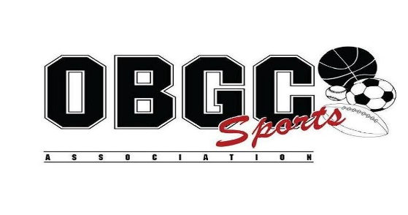

Dear OBGC Families,

Based on current recommendations from the CDC, Maryland Department of Health, and the Governor of Maryland’s Executive Orders, OBGC Park and all OBGC programs are postponed until at least April 24, 2020. All team events, tournaments, leagues, and practices scheduled during this time are cancelled.

Our staff is working on different scenarios depending on if/when the coronavirus restrictions are eased. The health and safety of our OBGC families is always the highest priority for us and we will continue to follow the guidance of the various governmental and health related agencies during this crisis. If the entire spring season is cancelled, we will have a plan in place to credit or refund each families spring OBGC fees. Any questions can be directed to Ken Bradford at Director@obgc.com.

Sincerely
OBGC

